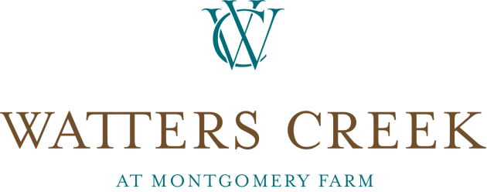

**Watters Creek Welcomes Birds & Words Pop-Up Location**

|  |
| --- |
|  |

**ALLEN, Texas (****Aug. 26, 2019)** – [Watters Creek](http://www.watterscreek.com) at Montgomery Farm welcomes a pop-up location [of Birds & Words – a home boutique](https://birdsandwords.org/).

This pop-up location of Birds & Words, a family-owned store offering unique, repurposed and reclaimed home items, is now open at Watters Creek through January 2020. With this timing, the Watters Creek location will offer the vast variety of home décor and furniture Birds & Words is known for with a special holiday emphasis, including fall décor, such as handmade fabric pumpkins, and Christmas items, such as ornaments. Birds & Words’ first store is located in downtown McKinney.

“We are always striving to offer a wide variety of stores and options for our guests, and this Birds & Words pop-up location will be a great new addition for the fall and holiday season,” said Debra Martinez, marketing director for Watters Creek at Montgomery Farm. “With a holiday-themed twist on the variety of items Birds & Words is known for, Watters Creek guests will be able to find festive and unique things.”

The Birds & Words pop-up, which is more than 2,000 square feet, is now open at 857 Watters Creek Blvd., next to Bath & Body Works. The store is open Monday through Saturday from 10 a.m. to 9 p.m., and Sunday from noon to 6 p.m.

“In looking for a second location, we felt Watters Creek was a perfect fit, as it offers a unique atmosphere where something is always going on, making it a place people want to come often,” said Colin Conn, owner of Birds & Words. “We search for unique items, such as furniture from Europe along with handmade items made here in North Texas that our guests can’t get anywhere else, and we are thrilled to bring these and our holiday décor to Watters Creek.”

Watters Creek has had several openings in the past few months, including [Venetian Nail spa](https://www.watterscreek.com/store/Venetian-Nail-Spa/2138956011/), along with several restaurants, such as [Edith’s French Café](https://edithscafe.com/), [Fish City Grill](https://fishcitygrill.com/) and [Snappy Salads](https://www.snappysalads.com/). For a complete list of Watters Creek offerings, please visit <https://www.watterscreek.com/directory/>.

For the most up-to-date information visit the Watters Creek Facebook page or website at <http://www.watterscreek.com> or follow the shopping center on [Facebook](https://www.facebook.com/watterscreek), [Twitter](https://twitter.com/WattersCreek) and [Instagram](http://instagram.com/watterscreek). Watters Creek is located at the intersection of US 75 at Bethany Drive in the heart of Allen, Texas. For more information, call 972-747-8000 or visit [www.watterscreek.com](http://www.watterscreek.com/).

**CONTACT:**

Allison Klingsick:

Sunwest Communications

469.547.0211

[aklingsick@sunwestpr.com](mailto:aklingsick@sunwestpr.com)

Debra Martinez

Marketing Director

Watters Creek

972.747.8000

[dmartinez@trademarkproperty.com](mailto:dmartinez@trademarkproperty.com)

**About Watters Creek at Montgomery Farm**

Watters Creek at Montgomery Farm is a premier, resort-style shopping and entertainment destination in North Dallas set within 52-acres of lush landscaping and natural features that include a village green and running creek. The mixed-use development offers a vibrant combination of nationally-renowned retailers, local boutiques, restaurants, office space and high-end loft apartments. In 2016, Watters Creek was honored with a prestigious Obelisk Award from the National Business Council for the Arts. Built in 2008, Watters Creek was the first retail development in the State of Texas to be LEED-certified by the U.S. Green Building Council.

**About Trademark Property Company**

Trademark Property Company is a full-service real estate firm focused on investments, development and institutional services of experiential, mixed-use and daily needs properties. In its years of business, Fort Worth, Texas-based Trademark has invested in, developed or redeveloped 18 million square feet of retail and mixed-use assets worth $3.9 billion. Trademark’s experienced team of more than 180 employees is currently responsible for a 17-property portfolio totaling approximately 10.2 million square feet of retail and mixed-use projects across the country. A leader in navigating the changing retail landscape, Trademark’s purpose is to be extraordinary stewards, enhance communities and enrich lives. For more information, visit [www.trademarkproperty.com](http://www.trademarkproperty.com) or interact on [Facebook](https://www.facebook.com/tdmkproperty), [Twitter](https://twitter.com/TrademarkFW) and [Instagram](https://www.instagram.com/trademarkproperty/).

###